|  |
| --- |
| Realtime automation Incorporated |
| Vilter 25972XP Explosion Proof Actuator User’s Guide |
| Revision 6.19 01/08/2021 |

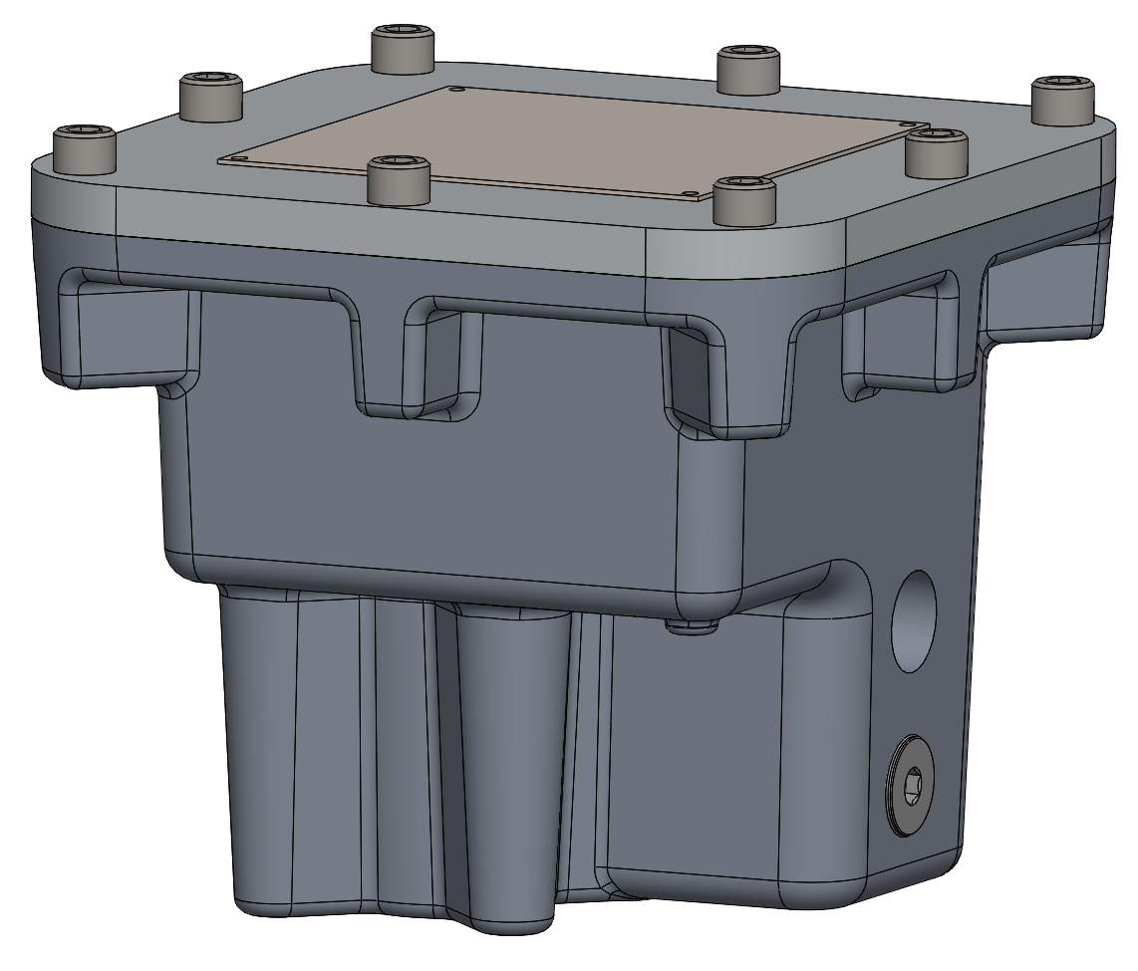

# Introduction

The 25972XP is an explosion proof rotary slide valve actuator certified for use in class 1 division 1 hazardous locations. It features a brushless DC motor, an electro-mechanical brake, absolute position sensing, a maximum span of 12 turns of the output shaft, automatic calibration and many input and output configurations.

## Specifications

|  |  |
| --- | --- |
| Mechanical | 600 in-lbs. (68 Nm) run torque limit  360 in-lbs. (41 Nm) calibration torque limit  No load speed 1.67 rpm.  12 output shaft turns maximum span. +/- 0.35 degrees positioning accuracy.  Electro-mechanical brake. |
| Electrical | 24VDC 1.5A peak.  BLDC motor.  Hall effect absolute position sensors.  Modbus readable temperature sensor.  RoHS compliant components rated for 105 deg. C. |
| Enclosure | 4X, IP67 |
| Hazardous Locations | See the *Hazardous Locations* section |
| Ambient | -20C to 80C (-40F to 185F)  Non-condensing relative humidity |
| Set Point Inputs | Modbus RTU  4-20mA  pulse width modulation: 24 VDC@ 16mA, 124 VAC @ 8 mA or 240VAC @8mA depending on which circuit board is used |
| Other inputs | 24V 12mA pull low to stop or low for 2.5 seconds to start calibration  Push button on circuit board push to stop actuator, hold down for 2.5 seconds to start calibration |
| Position Outputs | Modbus RTU  4-20mA, 12V loop compliance  0-20mA, 12V loop compliance |
| Other outputs | 24V 12mA fault indicator  Circuit board LEDs |
| Modbus RTU Serial Communication | Two wire RS-485, 9600 Baud, no parity, eight data bits and one stop bit.  Switch selectable Modbus addresses of 20 or 21.  Implemented codes are 03 read multiple registers and 06 write single register. |
| Calibration | Automatic calibration by torque sensing.  Can be initiated by push button, Modbus or grounding the external calibrate terminal. |
| Weight | 10 LBs (4.5Kg) |

# Mounting Dimensions



# Installation

Insert the output drive socket of the actuator over the command shaft and slowly rotate while applying slight downward pressure until the square on the command shaft slides into the square in the drive socket. Rotate the actuator until the mounting bolt holes are in the correct position and then fasten the actuator to the compressor mounting using 5/16”-18UNC class 2A screws that thread into the actuator at least 5/8” (16mm). Use anti-vibration washers on the mounting screws. Torque the mounting screws to 108in-lb. (12Nm)

**Caution: The actuator can be damage by axial forces on the output shaft exceeding approximately 50 lbs. Take care not to use excessive force when installing the actuator onto the command shaft. Make sure that the actuator makes contact with the mounting surface on the compressor before tightening the mounting bolts**.

Wire the actuator for the desired inputs and outputs as explained in other parts of this manual.

## Wire Sizes

Size power supply wires so that the actuator can operate within a voltage window of 22.5V to 26.4V. The terminal blocks on the circuit board will accept a maximum of 18 gage wire. Extra wire can be stuffed in the compartment below the bell-mouthed conduit.

# Hazardous Locations

### Certifications

USA and Canada

25972XPxx Actuator 600#-in 24VDC 1.5A 100% duty cycle

Class 1 Division 1 Groups C & D T3C -40C < Ta < 85C, Enclosure 4X

Class 1 Division 2 Groups B, C & D T3

ATEX

25972XPxx Actuator 600#-in 24VDC 1.5A 100% duty cycle

Certificate Number QPS21ATEX1000X

|  |  |  |  |
| --- | --- | --- | --- |
| ce.gif |  | II 3 G Ex nA IIC T4 Gc  Ta: -20 ºC to +70 ºC | RoHS |

24VDC power must be supplied by a class 2 power supply.

To prevent ignition of hazardous atmospheres, observe these cautions: 1) All cover screws must be installed and tightened during normal operation. 2) When cover removal is necessary for calibration, only do so when the area cannot become hazardous.

When the actuator is controlled by a 240VAC pulse modulation control signal, the control signal must have transient protection suitable for the hazardous location.

For Class 1 Division 1 applications conduit runs must have a sealing fitting within 18 inches (0.5m) of the enclosure.

Authorizations to mark are in the appendices.

# Circuit Board

!- Shock Hazard

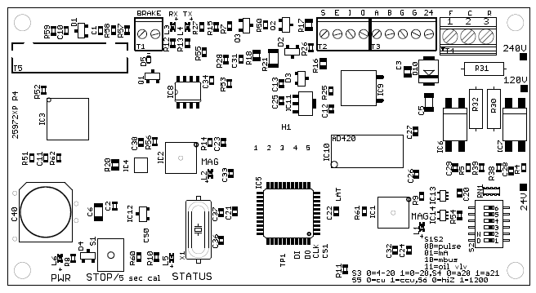

There are three versions of the circuit board that differ in the triac bleed resistors (R30, R31 and R32). The versions can be identified by which check box is marked on the right edge of the board. The connector wiring is given in the appendixes.

## T2, T3 & T4 External Connections Terminal Blocks

The terminal positions are labeled on the circuit board diagram.

|  |  |
| --- | --- |
| Terminal  Position | Signal |
| S | 24V 12ma external status. A high value indicates a fault condition. |
| E | 24V 12ma external calibrate. Pulling this terminal low starts the automatic calibration procedure. |
| I | 4-20mA positive input. |
| 0 | 0-20mA and 4-20mA positive output. |
| A | Modbus RTU A |
| B | Modbus RTU B |
| G | Two grounds. Use one ground for the negative of the 24VDC power supply and use the other ground for the negative of the 0-4-20mA input and output. Do not use the same ground for both power and instrumentation as this will cause electrical noise on the instrument lines. |
| 24 | +24VDC power. |
| F | Legacy pulse modulation forward. |
| C | Legacy pulse modulation common. |
| R | Legacy pulse modulation reverse. |

## Configuration Switches

The DIP switch S2 is where the I/O configurations are set.

|  |  |
| --- | --- |
| Switch Position | Configuration |
| 1 & 2 | S1 S2 Input Configuration  Off Off legacy pulse width modulation  Off On 4-20mA  On Off Modbus register 40200  On On Oil Valve |
| 3 | Off = 0-20mA output On = 4-20mA output. |
| 4 | Off = Modbus Address 20 On= Modbus Address 21 |
| 5 | Command shaft increase: Off = is clockwise. On = CCW.  Compressor Model specific, see Appendix E |
| 6 | Modbus RTU termination: Off = high impedance On = 1200 Ohm. |

## LEDs

|  |  |
| --- | --- |
| LED | Indication |
| RX | Modbus receive |
| TX | Modbus transmit |
| MAG | When lit, the adjacent position sensor chip, IC1 or IC2, is either too close or too far away from the shaft magnet. |
| POWER | Indicates 24VDC power to the board |
| STATUS | Displays status blink codes. See the blink codes section below |

# Modbus RTU RS-485 Communication

The physical network connection is two wire RS-485. The inverting (A) and non-inverting (B) wires connect to terminal block positions A and B. The Transmit (TX) and receive (RX) LEDs on the board give a visual indication of Modbus operation. The serial communication parameters are fixed at 9600 baud, no parity, eight data bits and one stop bit. The Modbus device address is jumper selectable to 20 or 21.

The Modbus codes that are implemented are:

* 03, read multiple registers
* 06, write single register

**Code 03 deviates from the Modbus standard in that it only returns the value of a single register, regardless of the number of registers requested.**

## Modbus Registers

There are three groups of Modbus registers: read only, read-write and read-write persistent. The values in the read-write persistent registers are stored in EEPROM memory and maintain their values between power cycles.

### Modbus Read Only Registers

|  |  |  |
| --- | --- | --- |
| Register Address | Function | Notes |
| 40100 | 16 bit actuator position | The range is 0 to 65535. See the *I/O granularity* section. |
| 40101 | Status register | See the *Status Bits Register* table. |
| 40102 | Temperature | The circuit board temperature in the vicinity of the motor. See the T*emperature* section. |
| 40103 | Span | Actuator span. See the *Calibration* section. |

### Modbus Read-Write Registers

|  |  |  |
| --- | --- | --- |
| Register Address | Function | Notes |
| 40200 | 16 bit position set point | Range 0 to 65535. See the section on I/O granularity below. |
| 40201 | Auto-calibrate | Writing a non-zero value to this register initiates automatic calibration. When the automatic calibration procedure is finished the register is reset to zero. See the calibration section below. |
| 40202 | Emergency Stop | Writing a non-zero value to this register disables the actuator motor. |
| 40203 | Position Sensors Status | Status bits for the AS5040 position sensors. Used for factory trouble shooting. |
| 40204 | Peak Motor current | See the *Motor Current and Actuator Torque* section. |
| 40205 | Peak Motor Current Position | See the *Motor Current and Actuator Torque* section. |
| 40206 | Status Register Value at Last Fault | Status register value for last error |

### Modbus Read-Write-Persistent Registers

|  |  |  |
| --- | --- | --- |
| Register Address | Function | Notes |
| 40300 | Calibrate Current | Default 420 range 200 to 600 |
| 40301 | Maximum Current | Default 320 range 200 to 600 |

# Motor Current and Actuator Torque

Motor current is a proxy for actuator torque. The formula for converting the current value in registers 40204, 40205, 40300 and 403001 is actuator torque = 0.53*register value + 58. This formula is only approximate and the actual torque vs current relationship varies from actuator to actuator.

Because of this variation, values can be written to Modbus registers 40300 and 40301 that override the auto-calibration trip current and the normal operation trip current respectively. The range of values that can be written to these registers is 200 to 600. The default value for register 40300 is 320 and the default value for 40301 is 420.

Modbus registers 40204 and 40205 are diagnostic registers that retain the peak motor current and the location where the peak current occurred since the registers were last cleared. The registers are cleared by writing zero to them. The location where the peak torque occurred as a percentage of span = 100*(register 40204 value)/ (register 40103 value)

When the maximum torque limit (motor current limit) is exceeded during normal operation the motor is powered off for approximately six seconds and then powered on again. This allows the actuator to surge against a stuck valve and possibly free it.

## Register 40101 Status Bits and 40206 Status Bits for Last Error

|  |  |  |
| --- | --- | --- |
| Bit Position | Function | Notes |
| 0 | Calibrated | 1 = the actuator is calibrated. |
| 1 | Span Error | 1 = the calibration failed because the span was too small. |
| 2 | Backlash | 1= there is gear backlash that may be causing positioning errors. |
| 3 | Position Sensor 0 Error | 1 = a hardware fault for the AS5040 position sensor above the output shaft. If the LED adjacent to the chip is glowing, it means that the shaft mounted magnet under the chip is too close or too far away. |
| 4 | Position sensor 1 Error | 1 = a hardware fault for the AS5040 position sensor above the shaft driving the output shaft. See comments above. |
| 5 | Over Temperature | 1 = the board temperature is >= 92 degrees Celsius. See the *Temperature* section. |
| 6 | Over Current | 1 = the motor current has exceeded the trip current. This resets every several seconds and the actuator again tries to move past the mechanical resistance causing the over-current. See the *Motor-Current* section. |
| 7 | Past Span | 1 = the actuator position is outside of the calibration span. This is usually caused by overshoot of the PID positioning algorithm. |
| 8 | EEPROM error | 1 = EEPROM memory read error. |
| 9 | Emergency Stop | 1 = an emergency stop command has been issued through either Modbus or the push button. |
| 10 | Reverse Acting | 1 = reverse acting. |
| 11-12 | Set Point Source | Bit 11 Bit 12 Source  1 1 Legacy pulse modulation  1 0 Modbus  0 1 4-20mA |
| 13-15 | Not used |  |

There is a spreadsheet available to decode this and other registers.

# Automatic Calibration, Setting the Span

When automatic calibration is initiated, the actuator determines the span by moving CCW and then CW until the calibration torque thresholds are reached and then backing off from these limits by three degrees. The span is stored in Modbus register 40103. To convert the span value into degrees, divide by 2.844. This value is six degrees smaller than the actual stop to stop travel distance of the valve.

Automatic calibration can be initiated one of three ways: the cal/stop button can be held down for >2.5 seconds, a non-zero value can be written to Modbus register 40201, or the external calibration line can be pulled low for >2.5 seconds. During automatic calibration the status LED displays the calibration blink code. **Automatic calibration can be halted in an emergency by depressing the cal/stop button, setting the Modbus register 40201 to zero, or pulling the external calibration line low.**

The actuator will not respond to set point input until it is calibrated. When the actuator is not calibrated the status LED displays the not calibrated blink code.

The actuator cannot be brought into automatic calibration mode if it has shut down on over-temperature. Once the actuator has cooled to where its temperature is below the threshold, then it can be calibrated.

# I/O Granularity

The actuator has a maximum span of 13 turns with a resolution of 10 bits per turn, thus making the maximum **internal** span 13311.

The actuator position is a 16 bit unsigned integer that located in Modbus register 40100 and is converted to a 4-20mA signal with 16 bits resolution. The position is calculated by the formula:

Position = 65535*(internal position/internal span)

The internal position and internal span will usually be significantly less than 65535. As a consequence there will be values that will never appear in the output position. This can be a source of disagreement between the set point in Modbus register 40200 and the actuator position in register 40100 after the actuator has settled to a new position.

# Forward/Reverse Action

Forward/reverse acting is configured by a configuration switch setting. See *Configuration Switches* table above.

# Set Point Input

There are four methods of set point input. See *Configuration Switches* table above.

## Pulse Modulation

This is the Vilter legacy motor control three wire input. The wires connect to the board at terminal positions F (forward), R (reverse) and C (common). The input voltage is determined by which model circuit board is installed. The available control signal voltage options are 24VDC, 120VAC and 240VAC – depending on the circuit board used. The circuit board will be marked for the intended control signal voltage. For 24VDC operation make the (C)ommon terminal negative. **For 240VAC operation, the control signal must be protected from high voltage transients by a suitable transient suppression device**.

When voltage is applied across terminals F and C then the actuator will move in the forward or increase direction until the voltage is removed or the end of the span is reached. When a voltage applied between the R and C terminals then the same happens in the reverse direction. When voltages are simultaneously applied across F and C and across R and C, the actuator does not move.

## 4-20mA

4-20mA input is connected to the board at terminal positions I (positive) and C (negative). The actuator positions itself within the span proportional to the input current. The actuator will stop on the loss of the 4-20mA signal.

## Modbus

The actuator positions itself within the span proportional to the value in the Modbus register 40200. The values can range from 0 to 65535. See the explanation on position output granularity above.

# Position Output

Three position outputs are available: See *Configuration Switches* table above. Modbus register 40100 is always available. Modbus register 40100 contains the 16 bit unsigned position, proportional to the actuators current location within the span. See the discussion on output granularity above. The current output terminal positions are O (positive) and G (negative).

The position outputs are updated every 10mS. The maximum compliance of the milliamp output is 10V. Legacy 0-5V output can be obtained by placing a 250 Ohm 1/4 Watt resistor across the input terminals of the receiver.

# Temperature Sensor

There is a temperature sensor mounted on the circuit board and located above the motor with a measurement range of -40 deg. C to 125 deg. C. The value is stored in Modbus register 40102. The Centigrade temperature = (Register 40102 Value – 102.3)/2.046. When the temperature exceeds 100 deg. C (Register 40102 value = 306) power will not be supplied to the motor to prevent over-heating.

# Actuator Life

The actuator life is mostly dependent on the torque. Environmental factors such as extreme vibration or extreme climate can also affect life. The usual mode of failure is fatigue of the output gear teeth. The life of the actuator for this mode of failure is approximated by the equation L = 4.4*10^15/T^5.076 where:

* L is the life in the number of load and unload cycles of the output gear teeth.
* T is the output torque in inch-pounds.
* There are 54 teeth on the output gear.

# Speed vs Load Torque Equation

The relationship of the torque and speed of the output shaft is given by the following formula:

RPM = 1.53-0.01*Torque(ft* lb) at 24V power

# Status LED Blink Codes

Besides Modbus, the actuator communicates status information to the operator by blink codes through the status LED. In the blink codes **1 = LED** on and **0 = LED** off. Time increases from left to right and the pattern repeats once the end of a sequence is reached.

|  |  |
| --- | --- |
| Blink Code | Meaning |
| ‘0011001100110011  (uniform blink) | The actuator is in the process of auto calibrating. |
| ‘0000000000000001 | The actuator is not calibrated. Possible causes:   * Automatic calibration failed because the span was too small. This can be caused by a sticking valve. * Automatic calibration was stopped before it was completed. * EEPROM memory failure is preventing stored calibration data from being read. |
| ‘1111111111111111  (steady glow) | Hardware error. Possible causes:   * Excessive backlash from worn or broken gears * Shaft magnets are too close or too far from position sensor chips. * Position sensor chip failure |
| ‘0000000000010101 | The actuator temperature exceeds 100 degrees Celsius. Normal operation resumes after it cools. |
| ‘0000000000000101 | The actuator torque limit has been exceeded. The actuator will pause 6 seconds and then try to move again. |
| ‘1111111111111110 | An emergency stop command has been issued through either Modbus or the CAL/STOP push button. |

# Actuator Models

The base actuator can be configured Some use different protection methods

|  |  |  |  |  |
| --- | --- | --- | --- | --- |
| Part No | I/O Configuration | Connector(s) | Hazardous Locations | Wiring Legend |
| 25972XP1 | 4-20mA | 10-pin Turck Ex-proof feed-through receptacle | C2 D2 B,C,D US & CAN  ATEX Z2 C3 IIC | Appendix A |
| 25972XP2 | 24DC -120VAC PWM  Note 1 | 5-pin Turck receptacle  4-pin Turck receptacle | C2 D2 B,C,D US & CAN  ATEX Z2 C3 IIC | Appendix B |
| 25972XP3 | All I/0 options with 24-120V PWM | C1 D2 wiring methods | C1 D2 C,D US & CAN  C2 D2 B,C,D US & CAN  ATEX Z2 C3 IIC | Circuit Board  Section |
| 25972XP4 | All I/0 options with 240V PWM | C1 D2 wiring methods | C1 D2 C,D US & CAN  C2 D2 B,C,D US & CAN  ATEX Z2 C3 IIC | Circuit Board  Section |
| 25972XP5 | 4-20Ma | 6-pin Turck Ex-proof feed-through receptacle | C2 D2 B,C,D US & CAN  ATEX Z2 C3 IIC |  |
| 25972XP6 | 240VAC PWM  Note 1 | 5-pin Turck receptacle  4-pin Turck receptacle | C1 D2 C,D US & CAN  C2 D2 B,C,D US & CAN  ATEX Z2 C3 IIC | Appendix B |

Note 1: The circuit board for 24-120V PWM and the circuit board for 240V PWM have different bleed resistors for the external triacs installed.

The actuator uses the explosion proof protection method for hazardous locations. Turck manufactures explosion proof feed-through receptacles that maintain this protection method when installed in the actuator.

With Turck explosion proof receptacles, the actuator can be used in Class 1 Group C,D Division 2 locations with suitable Turck cord sets.

Electrical codes require that receptacles cannot be disconnected without the use of a tool. Turck manufactures locking devices that snap over the cord set and receptacle and meet this requirement. Some Turck cord sets have a set screw on the threaded collar that meet this requirement without a locking device.

# Appendix A

## 25972XP1 Connector Pinout and Configuration Switch Settings

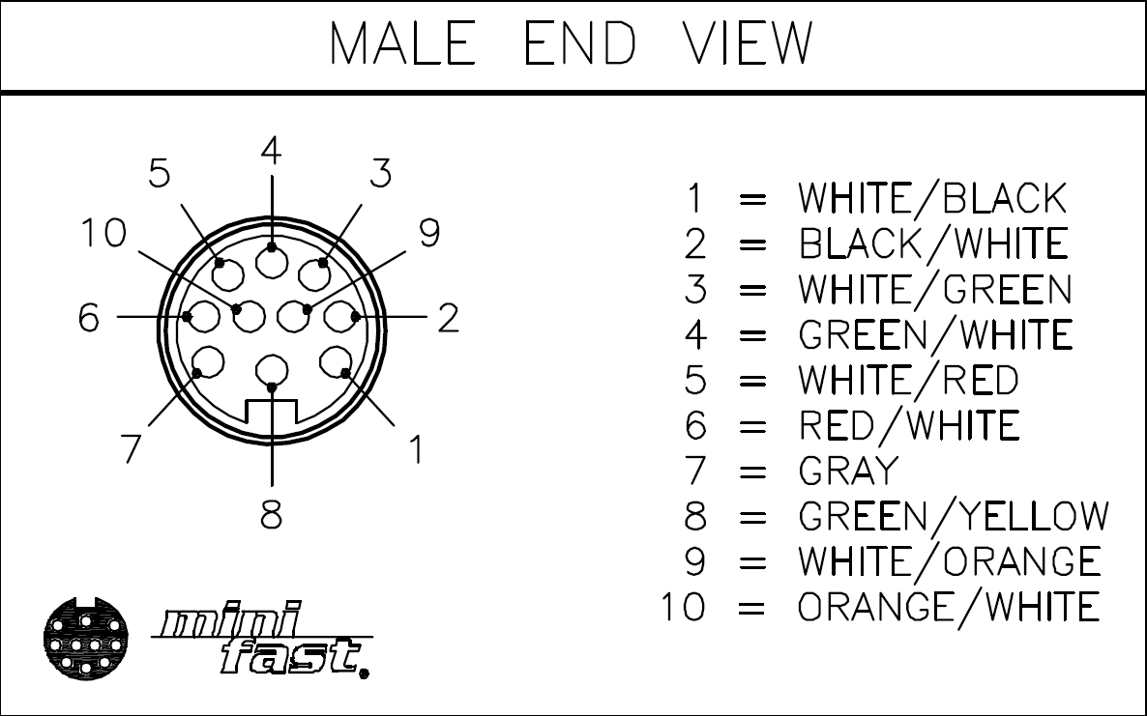 **Turck P-RSFV 101 EX-*/14.5/NPT**

|  |  |  |
| --- | --- | --- |
| **Pin #** | **Board Terminal** | **Function** |
| **1** | **+24V** | **Motor power +** |
| **2** | **G(1)** | **Motor power -** |
| **3** | **I** | **4-20mA input** |
| **4** | **G(2)** | **Instrument common** |
| **5** | **O** | **4-20mA output** |
| **6** | **G(2)** | **Instrument common** |
| **7** | **Case ground screw** | **Shield** |
| **8** | **Case ground screw** | **Earth ground** |
| **9** | **S** | **Status** |
| **10** | **E** | **External Calibrate** |

**Configuration Switch Settings**

|  |  |  |  |  |  |  |
| --- | --- | --- | --- | --- | --- | --- |
| **Position** | **1** | **2** | **3** | **4** | **5** | **6** |
| **Setting** | **Off** | **On** | **On** | **Either** | **Appendix A** | **Either** |

# Appendix B

## 25972XP2 Connector Pinout and Configuration Switch Settings

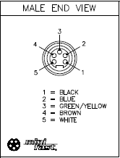 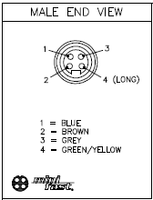

**Turck P-FSFV 56 EX-*/14.5/NPT Turck P-FSFV 40D EX-*/14.5/NPT**

**Turck P-FSFV 56 EX-*/14.5/NPT**

|  |  |  |
| --- | --- | --- |
| **Pin #** | **Function** | **Board Terminal** |
| **1** | **24V- Power** | **24** |
| **2** | **0-20mA Output+** | **O** |
| **3** | **0-20mA Output-** | **G(2)** |
| **4** | **Status** | **S** |
| **5** | **24V+ Power** | **G(1)** |

**Turck P-FSFV 40D EX-*/14.5/NPT**

|  |  |  |
| --- | --- | --- |
| **Pin #** | **Function** | **Board Terminal** |
| **1** | **Pulse Width Modulation Common** | **C** |
| **2** | **Pulse Width Modulation Forward** | **F** |
| **3** | **Pulse Width Modulation Reverse** | **R** |
| **4** | **Casing Ground** | **None (Green Screw)** |

**Configuration Switch Settings**

|  |  |  |  |  |  |  |
| --- | --- | --- | --- | --- | --- | --- |
| **Position** | **1** | **2** | **3** | **4** | **5** | **6** |
| **Setting** | **Off** | **On** | **On** | **Either** | **Appendix A** | **Either** |

# Appendix E

## Configuration SW Pos 5 Setting for Vilter Single Screw Compressors

|  |  |  |
| --- | --- | --- |
| Compressor Model Number | Capacity Slide Valve | Volume Slide Valve |
| 71 VSM / VSG | CW | CW |
| 91 VSM / VSG | CW | CW |
| 101 VSM / VSG | CW | CW |
| 111 VSM / VSG | CW | CW |
| 151 VSM / VSG | CW | CW |
| 152 VSM / VSG | CW | CW |
| 181 VSM / VSG | CW | CW |
| 182 VSM / VSG | CW | CW |
| 201 VSM / VSG | CW | CW |
| 202 VSM / VSG | CW | CW |
| 291 VSM / VSG | CW | CW |
| 301 VSM / VSG | CW | CW |
| 341 VSM / VSG | CW | CW |
| 361 VSM / VSG | CW | CW |
| 401 VSM / VSG | CW | CW |
| 451 VSM / VSG | CW | CW |
| 501 VSM / VSG | CCW | CCW |
| 601 VSM / VSG | CCW | CCW |
| 601 VSS / VSSG | CW | CW |
| 701 VSS / VSSG | CCW | CCW |
| 751 VSS / VSSG | CCW | CCW |
| 791 VSS / VSSG | CCW | CCW |
| 891 VSS / VSSG | CCW | CCW |
| 901 VSS / VSSG | CCW | CCW |
| 1051 VSS / VSSG | CCW | CCW |
| 1201 VSS / VSSG | CCW | CCW |
| 1301 VSS / VSSG | CCW | CCW |
| 1501 VSS / VSSG | CCW | CCW |
| 1551 VSS / VSSG | CCW | CCW |
| 1801 VSS / VSSG | CCW | CCW |
| 1851 VSS / VSSG | CCW | CCW |
| 2101 VSS / VSSG | CCW | CCW |
| 2401 VSS / VSSG | CCW | CCW |
| 2601 VSS / VSSG | CCW | CCW |
| 2801 VSS / VSSG | CCW | CCW |
| 3001 VSS / VSSG | CCW | CCW |

# 

